WKF RULES
In GKI tournaments, variations on the rules, which do not impact safety, may be decided upon by the tournament organisers. However, GKI will adhere to WKF rules as far as practicable.

SCORING
The scoring areas are :
Head Face Neck Abdomen Chest Back Side
(The back excludes the shoulders but includes the shoulder blades.)
For a technique to score, its performance must have:
Good Form; Sporting Attitude; Vigorous Application; Good Timing; Correct Distance;
Awareness (Zanshin). Turning away will void a technique which might have scored.
No score can be awarded for a technique delivered by a contestant touching outside the area.
JODAN scoring distances are…
Adults and ages 16 to 18 - from skin touch to 5 cm for kicks and skin touch to 2cm for hand techniques. (Skin touch means the lightest touch - no impact)
Ages 14 and 15 - from skin touch to 5 cm for kicks and NO skin touch to 2cm for hand techniques.
For ages under 14 scoring distances are under 10cm for kicks and 5 cm for hand techniques. No contact whatsoever is permitted – no skin touch.
Techniques to the CHUDAN area may be delivered with controlled impact without causing injury to the opponent. A loss of breath by the recipient of a blow does not in itself indicate lack of control.
Any contact disallowed by these rules, no matter how light, will be penalised, unless caused by the recipient (MUBOBI).
No contact to the throat whatsoever is allowed in any match.

SCORE ASSESMENT AND VALUES
A majority decision of the judges will decide whether a technique scored. If only two judges show a score / warning / penalty for the same competitor, the referee is obliged to stop the bout and normally award the score.
If there are only two judges, then the referee includes his assessment when awarding a score. A score will be awarded if the two judges indicate for the same competitor or the referee stops the bout for a technique that he has seen and one or two judges indicate the same score.
In a 4 judge situation…
- If 2 Judges indicate a score for the same competitor, but the Referee has seen a contact, he may communicate this to the Judges with the appropriate signal.
- If 2 Judges signal a contact and 2 Judges a score for the same competitor, the Referee will decide what action to take. Also applicable in other 2:2 situations when it is possible to give only one decision (Mubobi Aka / contact AO)
- If the referee stops the bout without two judge’s indication, they then should indicate what they saw and the Referee then needs the signal of minimum 2 Judges for the same competitor to establish a score / warning / penalty.
- If two judges show a score for one contestant and two show for the other, BOTH contestants score. However, this should only apply if the techniques are exactly simultaneous.
- If all judges signal for one competitor, but only two judges show the same score, the referee should award that score.
- If only two judges signal but show different scores or warnings/penalty for one competitor, then the referee will award the lowest score or warnings/penalty.
No scores or JOGAI penalties can occur after YAMAE or the sounding of the bell for the end of the bout. Penalties can be awarded after YAMAE and after the final bell.
If a competitor performs more than one scoring technique before YAMAE, the higher score will be awarded.
The scores are….
YUKO (1 point) is scored for Chudan or Jodan Tsuki or Uchi
WAZA-ARI (2 points) is scored for Chudan kicks (Abdomen, Chest, Back, Side)
IPPON (3 points) is scored for Jodan kicks (head, face and neck) and any scoring technique delivered immediately to an opponent who has been thrown or has fallen, as long as the opponents torso is on the Tatami.

PROHIBITED BEHAVIOUR AND FOULS
The following will be penalised.
Techniques which make excessive contact, having regard to the scoring area attacked, and techniques which make any contact with the throat.
Attacks to the arms or legs, groin, joints, or instep.
Attacks to the face with open hand techniques.
Dangerous or forbidden throwing techniques.
Feigning, or exaggerating injury.
Exit from the competition area (JOGAI) not caused by the opponent.
Self-endangerment by indulging in behaviour, which exposes the contestant to injury by the opponent, or failing to take adequate measures for self-protection, (MUBOBI).
Avoiding combat as a means of preventing the opponent having the opportunity to score.
Passivity – not attempting to engage in combat. (Cannot be given after less than the last 10 seconds of the match.)
Clinching, wrestling, pushing, or standing chest to chest without attempting a a scoring technique or takedown.
Grabbing the opponent with both hands except for a takedown upon catching the opponents kicking leg.
Grabbing an arm or karategi with one hand without immediately attempting a scoring technique or takedown.
Techniques, which by their nature, cannot be safely controlled and dangerous or uncontrolled attacks.
Simulated attacks with the head, knees, or elbows.
Talking to, or goading the opponent, failing to obey the Referee, discourteous behaviour towards officials, or other breaches of etiquette.

WARNINGS AND PENALTIES
There are two types of Informal Warnings (where no penalty will result) :
TSUZUKETE is used for encouraging activity
WAKARETE is used for breaking up a clinch
Formal warnings/penalties normally go from
KEIKOKU - warning (no penalty score) to
HANSOKU CHUI - warning of disqualification (no penalty score) to
HANSOKU - penalty of disqualification.
A first infringement can attract any level of penalty. As a guide, a Keikoku is to be awarded if the opponent’s chances of winning are slightly diminished. (Hansoku-Chui if the foul caused a significant effect on the opponent’s chances).
The first instance of exaggeration of injury will receive a Keikoku, more serious cases can receive Hansoku Chui or Hansoku directly. Running away, clinching and other time wasting will be penalised. If there are less than 15 seconds to go, then the penalty will be at one level more severe than otherwise.
The judges (and arbitrator) must be consulted before a penalty is given. A clear sign from a judge is sufficient consultation.
SHIKKAKU is a disqualification and ban, with a public announcement and is imposed for harming the prestige of karate; not obeying the referee; being overly excited; committing deliberate fouls; not obeying the doctor; or feigning a non-existent injury.

CRITERIA FOR DECISION
An individual bout is won if one contestant reaches an 8-point advantage or has the most points at the completion of the match. If a bout reaches full time and the scores are even then the winner is the contestant with first unopposed point advantage (SENSHU).
If an individual bout reaches full time and the scores are even, without SENSHU, then a HANTAI majority decision will be made, with the Referee and Judges each having one vote. The decision is based upon the attitude, fighting spirit, and strength demonstrated; the superiority of tactics and techniques displayed and which of the contestants has initiated the majority of the action.
Should a competitor who has been awarded SENSHU get a Category 2 warning for avoiding combat when there is less than 15 seconds left, this advantage will be forfeited and the Referee will indicate TORIMASEN.
There can be draws in team matches. The winning team will be decided by number of wins, but if both teams have the same number of wins, then the total number of points is considered. If the teams are still level, then a deciding match will be fought.
In team matches where an individual loses by receiving KIKEN, HANSOKU or SHIKKAKU, any score for that Competitor will be set to zero, and a score of 8-0 will be recorded for that bout in favour of the other team.

CONTROL OF THE BOUT AND TIMING
Kumite individual competitors are divided by gender, age groups, and weight categories. Team competitions do not have weight categories.
The referee, competitors and officials bow SHOMEN NI REI then OTAGAI NI REI. At the end of the bout(s) the bowing is done in the opposite sequence. Competitors bow to each other before SHOBU HAJIME.
Coaches must stay on their place. A competitor may be disqualified due to actions of his coach or team.
The arbitrator will signal ATOSHIBARAKU at 15 seconds before the end of the bout.
An over 18 years male bout duration is 3 minutes, all others are 2 minutes but may be reduced from 3 minutes to 2 minutes and from 2 minutes to 1.5 minutes provided that this is announced prior to tournament start.
The timing of the bout starts when the Referee gives the signal to start and stops each time the Referee calls “YAME” or at the signal for full time. The timekeeper shall give a signal, indicating “15 seconds to go” by one short burst with the buzzer, and “time up” by two short bursts with the buzzer.

RENUNCIATION, ACCIDENTS AND INJURY
KIKEN means forfeiture and applies when a contestant refuses to continue the bout, is withdrawn on the order of the referee or abandons the bout.
If an injury has occurred the referee must call the doctor. An injured competitor may not continue if the doctor declares him unfit or if he has won a second bout on the disqualification, for fouls, of an opponent.
If a competitor falls, is thrown or is knocked down, he automatically is withdrawn if he does not regain his feet within 10 seconds. The ten seconds are counted by the referee and shown on his fingers. The Doctor is called.

SAFETY and EQUIPMENT
Competitors must have short fingernails and must not wear metallic or other objects, which might injure their opponents. Glasses are forbidden.
Approved protective equipment will be worn: red or blue mitts, gum shield; body protector plus female chest protector; groin box for men; shin pads and foot protection. (GKI may decide not to require body protector, face mask or helmet.

ANNOUNCEMENTS OF SCORES
These should be made by the referee as follows :
FIRST....  ....THINK | LOOK at contestant(s), NAME contestant | then EXPLAIN technique by words, gestures | and ANNOUNCE / SIGNAL using approved gesture and terms
NO SCORE  Ideally, referee should NOT stop the contest. |  | Torimsen gesture | TORIMASEN  TSUZUKETE  HAJIME
SCORE | AKA or AO | JODAN or CHUDAN  and TSUKI or UCHI or KERI | YUKO, WAZARI or IPPON  TSUZUKETE  HAJIME
WARNING  (no score) | AKA or AO | FOUL, JOGAI, MUBOBI etc  Use words and gesture's to explain foul, then show Cat 1 or Cat 2 sign | CHUKOKU, KEIKOKU, or HANSOKU CHUI  TSUZUKETE  HAJIME
PENALTY | AKA or AO  AO or AKA | Sign for CONTACT, JOGAI, MUBOBI DANGEROUS TECH, REPEAT ATTACK TO LIMB etc  Use gesture's to explain foul, show Cat 1 or Cat 2 sign, | HANSOKU or SHIKKAKU  NO KACHI
DECISION | AKA or AO |  | NO KACHI

OTHER TERMINOLOGY
AKA, AO | Red, Blue |  | SENSHU | First unopposed point
ATOSHI BARAKU | A little time left |  | SHUSHIN | Referee
FUKUSHIN | Judges |  | SHUGO | Judge called
HANTEI | Decision Request |  | SHOBU HAJIME | Contest - Begin
HIKIWAKE | Draw (only in team matches) |  | TORIMASEN | Not a scoring technique
KANSA | Arbitrator |  | TSUZUKETE | Continue – bring hands together
MOTO NO ICHI | Return to original positions |  | WAKARETE | Stop clinch – bring hands apart
NO KACHI | "is winner" |  | YAME | Stop

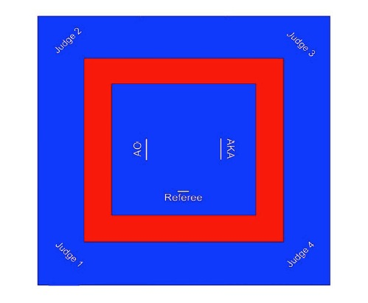
THE COMPETITION AREA
WKF rules state the fighting area will be 8x8 metre, matted, flat, free of hazard and have a 2m safety matted area. GKI may use a 7x7 metre fighting area for adults and appropriately smaller, if necessary, for children. The start positions are marked by short lines 2m apart, or by using two matts of a different colour.
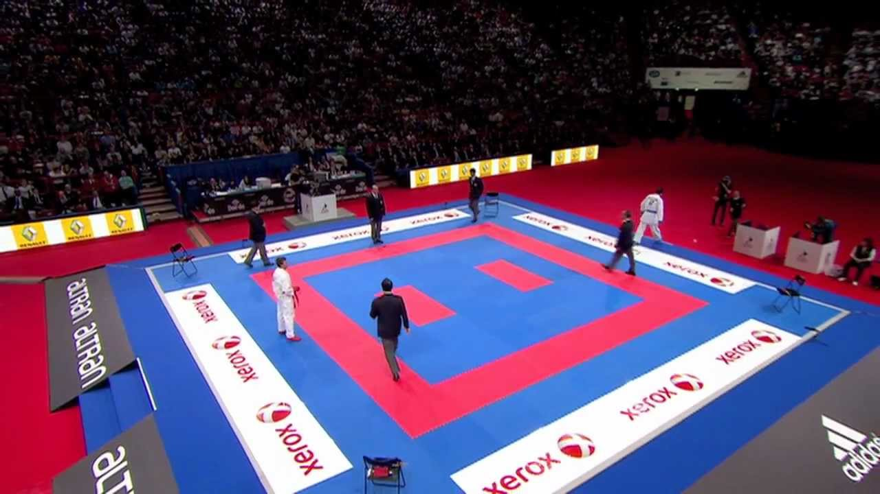
If there are four judges, they will sit at the corners. If two judges, they will sit 2/3 of the way down the sides. The supervisor, with a whistle and flag sits to one side of the timer/scorer table. The coaches will be on the opposite side.
The competitors wear either a blue (AO) or a red (AKA) belt and corresponding mitts and foot guards. GKI will only require the mitts and belt to be the same colour.

MISCELLANEOUS EXPLANATIONS:
- When a contestant is physically pushed or thrown from the area by the opponent, it is not Jogai
- Any discourteous behavior from a member of an official delegation can earn the disqualification (Shikkaku) of a competitor, the entire team, or delegation from the tournament.
- After a throw or the opponent has been grabbed onto, a technique must be performed immediately to score. Grabbing with both hands is a foul.
- 10-seconds-rule: Any competitor who falls, is thrown, or knocked down, and does not fully regain his or her feet within ten seconds, is considered unfit to continue so will be automatically withdrawn. The Judges will decide the winner on the basis of Hansoku, Kiken, or Shikkaku as the case may be. Whenever the 10 second clock has been started the doctor or first-aider must examine the contestant.
- Running, avoiding combat and jogai with less than 15 seconds of bout time remaining, receive a minimum Hansoku-Chui. Grabbing the opponent without attempting to throw or score within 2 seconds is also an instance of avoiding combat.
- A warning or penalty for Mubobi is given when a competitor is hit or injured through his or her own fault or negligence. In that case, the opponent must not be warned / penalised!
- Every warning / penalty can be given directly – depending on the severity of the offence / injury.
- Avoiding combat and jogai with less than 15 seconds to go is directly warned with Hansoku-Chui, exaggeration or feigning injury is directly warned / penalised with Hansoku-Chui or even Hansoku, or Shikkau can be given directly without any previous warning. Grabbing the opponent without attempting to throw or score within 2 seconds is also an instance of avoiding combat.
- For infringements Judges should first circle with the appropriate coloured flag then cross flags to their left for AKA, red flag in front, and to their right for AO, blue flag in front. This enables the Referee to clearly see which competitor is the offender.
- SENSHU cannot be applied if both competitors score before YAME. The first contestant to score without the other also scoring before YAME then has the SENSHU advantage.
- In a 4 judge situation…
- If 2 Judges indicate a score for the same competitor, but the Referee has seen a contact, he may communicate this to the Judges with the appropriate signal.
- TSUZUKTETE, unless preceded by WAKARETE, is not used if there is less than 15 seconds left of the bout.

